* **Activity 6:**

Applying Additional Conditions to a Join

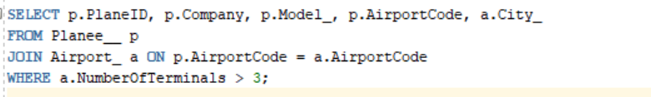

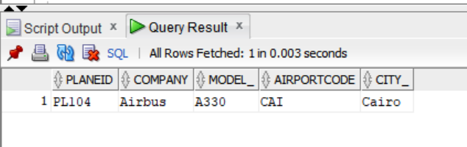

OUTPUT: